Community Needs Assessment Instructions

The Community Needs Assessment helps to understand how dementia friendly your community is today by identifying current resources, strengths and needs. With that information, your action team can develop a plan for your community to become more informed, safe, and respectful for people with dementia.

Because everyone can make a difference in how Alzheimer’s impacts a community, the assessment looks at all community areas that can touch people with dementia and their families and caregivers. When fully completed, the assessment provides a broad look at your community, covering key aspects of a dementia-friendly community. It provides an inventory of resources that support people with dementia and their caregivers and collects public opinion about action priorities for moving the community toward being dementia friendly.

Fit the Assessment to Your Community
Every community is different in its capacity to commit time and resources to conducting an assessment, its needs and opportunities for being dementia friendly, and its ability to prioritize and act on identified needs. Your team will need to decide how to approach the community assessment. Follow these steps:

Step 1: Review the Community Needs Assessment. Reading through all of the assessment questions will help your team understand the key aspects of a dementia-friendly community.
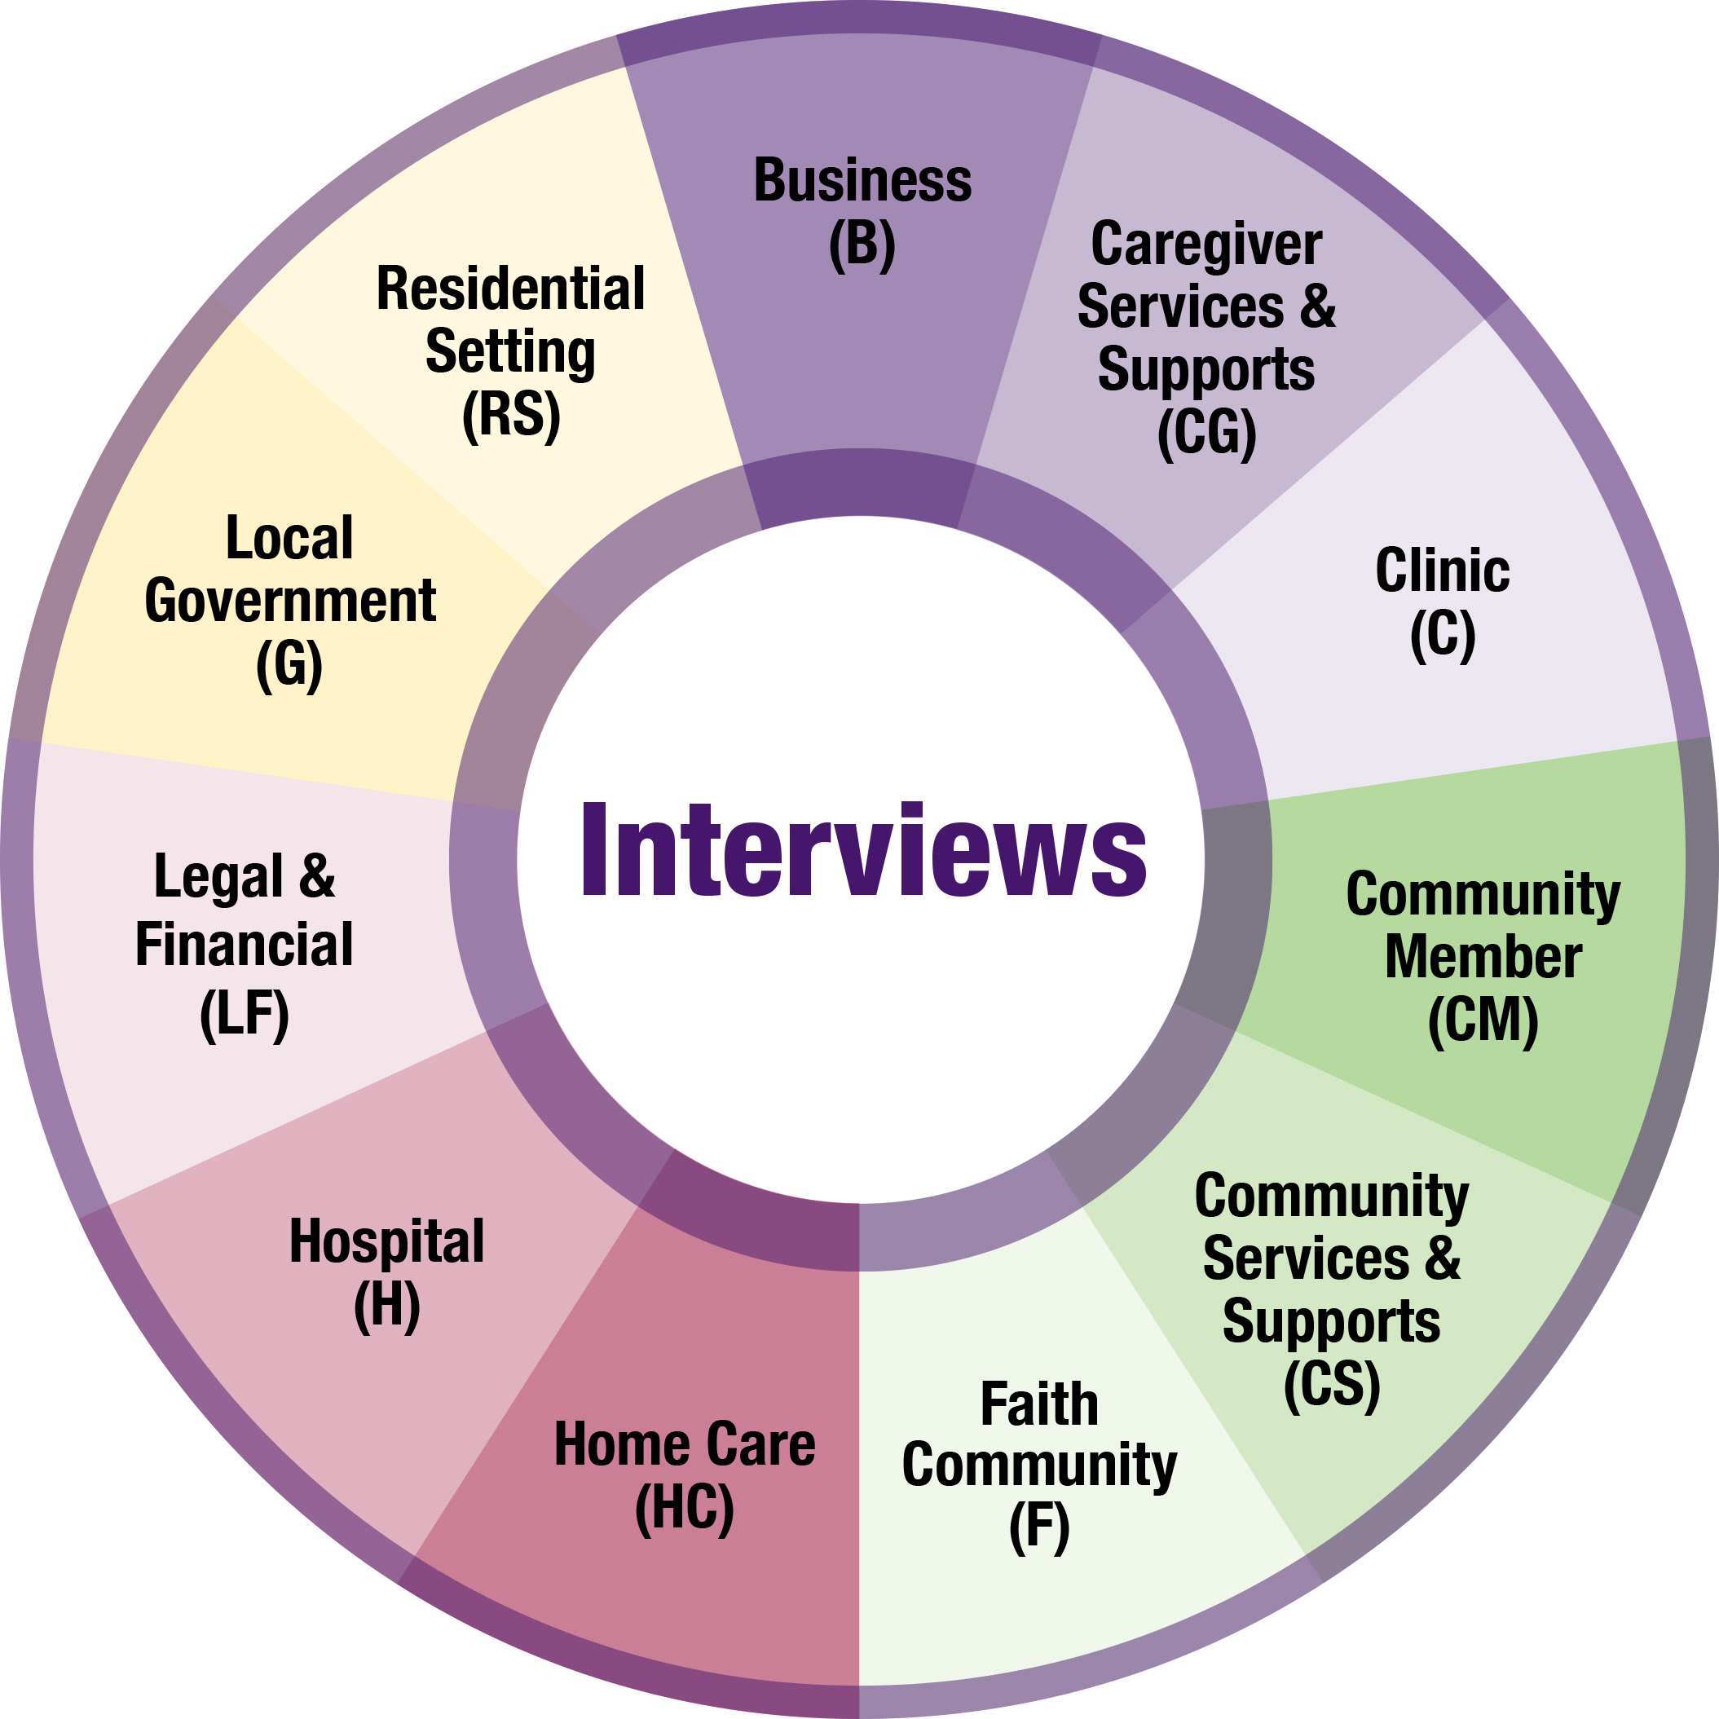
Step 2: Determine how much of the assessment is reasonable or appropriate for your team to complete. You might choose to use all 11 sector-based questionnaires or only those that are relevant or manageable. Realistically, your team may have limited capacity, knowledge, or connections to complete the assessment in full.

Step 3: Start with the resources you have and determine which community sectors are most relevant for your situation. Ideally, the assessment would be completed in full.

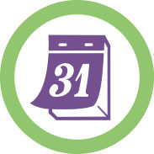
Plan on taking two to three months to complete the
community needs assessment in its entirety.

Think of these quotes as guiding principles when approaching this assessment and your work toward becoming a dementia-friendly community:

“Start where you are. Use what you have. Do what you can.” – Arthur Ashe

“Never doubt that a small group of thoughtful, committed people can change the world.
Indeed, it is the only thing that ever has.” – Margaret Mead

How to Complete the Assessment
After determining the parts of the assessment your team will complete, assign team members to compile a list of contacts to be interviewed and to conduct the interviews using the sector-based questionnaires. Team members will interview and engage community leaders and stakeholders who represent a cross-section of the community. These interviews will provide data to help you understand your community’s strengths and gaps. The questionnaires will introduce your team to community leaders and begin to build support for implementing dementia-friendly activities.

Use the 11 sector-based questionnaires to gather responses for the assessment. All of the questions in the sector-based questionnaires are cross-referenced back to the full assessment so your team can create a complete picture of your community.

The sector-based questionnaires will provide:
- Resource inventories existing in the community to meet the needs of people with dementia and their families.
- Community opinion and perceptions about current levels of dementia-related activity and priorities for action in your community.

Tools to Help Conduct the Interviews
The following tools will help your team conduct interviews for the community assessment:
- Pre-Interview Email Template or Call Script to introduce yourself and the project
- Materials to share with interviewees before or after they are interviewed:
  - Is Your Community Prepared flyer, includes dementia-friendly infographic
  - 10 Early Signs and Symptoms of Alzheimer's
  - Dementia-Friendly Sector Guides
  - Interviewee thank you letter
  - Sector-based questionnaires:
    - Business (B)
    - Caregiver Services and Supports (CG)
    - Community Member (CM)
    - Community Services and Supports (CS)
    - Faith Community (F)
    - Legal and Financial (LF)
    - Local Government (G)
    - Residential Setting (RS)
    - Health Care Community: Clinic (C), Home Care (HC), Hospital (H)

How to Organize Your Questionnaire Data
You have gathered a lot of data to help understand your community’s current strengths and opportunities for meeting the needs associated with Alzheimer’s disease and related dementias. Now it’s time to analyze that information to understand how your community can plan and take action.

You will compile the data from all of the completed sector-based questionnaires. Follow these steps to compile your questionnaire findings.

Step 1: Download and save a copy of the following data collection tools:
  - Community Needs Assessment
  - Level of Activity and Priority Rating Matrix Worksheets
  - Open-ended question worksheets for strengths, gaps and referrals (Questions 2-4 in full assessment)
  - Master Contact List spreadsheet for project involvement responses (Questions 26-28 in full assessment)
  - Assessment Priority Rating Spreadsheet

Step 2: Determine who will transfer information from the questionnaires into the tools. Find someone who is organized and is willing to type out handwritten information or copy and paste from electronic files.

Step 3: For each completed questionnaire, make sure each one has a unique code, using the sector abbreviation and a number. For example, clinic questionnaires would be C1 for first interviewee, C2 for second, etc.

Step 4: Level of Activity and Priority Rating Questions: Plot the level of activity and priority rating responses into the Level of Activity and Priority Rating Matrix Worksheets. See instructions and example on the following page and the toolkit video How to Use the Visual Matrices to Set Priorities.

Step 5: Check Box and Inventory Questions: For questions with answers like “yes/no” or “check all that apply,” tally the number of responses for each option and input into the Community Needs Assessment. Transfer inventory responses into the Community Needs Assessment as well. Example of an inventory question is “List the trainings and briefly describe.”

Step 6: Open-ended Questions: The assessment has two sets of open-ended questions. Two about strengths and gaps (Questions 2 and 3 in the full assessment) and one about referrals (Question 4 in the full assessment)

Step 7: Project Involvement Questions: The assessment has three questions to solicit interest and involvement in this dementia friendly community work.

Note: Many questions have two parts 1) an inventory question and 2) a level of activity and priority rating question.

Example: Plotting Level of Activity and Priority Rating
For Level of Current Activity and Priority for Action questions, plot individual responses into the matrices using the codes for each interviewee. Here is an example using question 24 (Q24) from the full assessment. This question is asked in the following sector-based questionnaires:

- Home Care (HC)
- Hospital (H)
- Residential Setting (RS)

Plot responses from each interviewee onto the corresponding matrix to indicate the interviewee’s opinion about the level of current activity and priority for taking action. For example, interviewee HC1’s response to this question is plotted in the chart below.

Level of Current Activity | Priority for Action
Indicate your level of agreement with this statement: Health care staff in our community receive adequate training on dementia. | Indicate your level of agreement with this statement: Increased training for health care staff on dementia should be a priority for action in our community.
1. Strongly disagree  2. Disagree  3. Neither agree or disagree  4. Agree  5. Strongly agree  0. Do not know | 1. Strongly disagree  2. Disagree  3. Neither agree or disagree  4. Agree  5. Strongly agree  0. Do not know

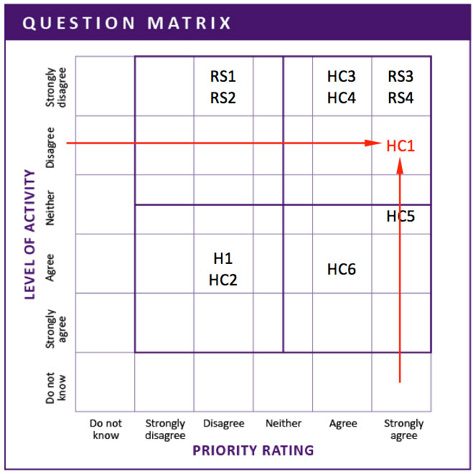
To plot responses on the matrix, find the interviewee's responses on both the vertical axis (Level of Activity) and horizontal axis (Priority Rating). Draw imaginary lines from each response into the matrix. Plot the interviewee code in the box where the lines meet.

All of the responses from the three sector-based questionnaires (HC, H, RS) are plotted in the sample matrix at right, with the HC1 response note in red.

Example: Check Box Questions
For check box questions, with answers like “yes/no” or “check all that apply,” tally the number of responses for each option and input into the Community Needs Assessment. Below are examples from the Community Services and Support Questionnaire and the table for the tallied data from all questionnaires.

Sector Questionnaire: Do you currently offer any of the following counseling/support groups for caregivers of people with dementia? Are they tailored to people with dementia? (Q12 in full assessment)

Inventory of counseling and support groups specific for caregivers of people with dementia | Currently available?
Family counseling/Family meeting | ___ Yes | ___ No
Support groups | ___ Yes | ___ No
Mentoring program/Peer support | ___ Yes | ___ No
Other (please specify) | ___ Yes | ___ No

Community Needs Assessment: Tally responses of all questionnaires below. Add rows to the table as needed. You can choose to develop a detailed list of organizations that provide these services now or wait to see if your community identifies a priority for action that requires this information (be sure to retain the individual questionnaires).

Inventory of counseling and support groups specific for caregivers of people with dementia | Currently available?
 | Yes | No
Family counseling/Family meeting | 3 | 4
Support groups | 3 | 4
Mentoring program/Peer support | 0 | 0
Other (please specify) | 0 | 0

Strengths and Gaps Questions
Strengths and gaps questions are intended to get the pulse of your community. When you compile these responses, you will look for themes. Ideally these themes will correspond to the items that rise up as priority actions for the community to undertake to become dementia friendly. Use this qualitative data to aid in priority-setting discussions.

The two open-ended questions for strengths and gaps (Questions 2 and 3 in the Community Needs Assessment) each have their own worksheet to summarize community input. Worksheet instructions:

- Type up responses to the question from all 11 questionnaires.
- Group similar responses into themes.
- Write a description of each theme and record in the worksheet. Add rows as needed.
- Record number of similar comments in grouping.

Referral Question
The referral question (Question 4 in the Community Needs Assessment) has its own worksheet for tracking responses. This question provides insight into your community’s awareness of the resources and organizations to support those individuals who may show signs of dementia. Use this information if your community identifies awareness as a priority. Worksheet instructions:

- Type up responses to the question from all 11 questionnaires.
- Indicate how many people noted the same referral. Add rows as needed.

Project Involvement Questions
Answers to questions from the Project Involvement section can be entered into the Master Contact List spreadsheet (Questions 26-28 in Community Needs Assessment). Use the information from these following questions to add to or create your interested parties list.

- Would you be interested in helping us create a dementia-friendly community?

Suggestions:
  - Serve on the action team
  - Public endorsement/testimonial
  - Donate resources, e.g., meeting space, advertising, personnel, funds, etc.

- What other organizations/groups in our community should take part in creating a dementia-friendly community?

- Should I get in touch with you again to let you know how the project is progressing and how you can best help to ensure our community is becoming dementia friendly?

How to Analyze Your Assessment Data
Once all of the data has been compiled into the worksheet, your action team needs to analyze that data and make decisions on the top priorities for the Phase 4 Community Action Plan Workplan. Remember, this is not a scientific research study. It is a conversation with your community to gauge readiness, raise awareness and create momentum for change. Don’t be overwhelmed by all of the information your team has gathered. It’s a sign you have successfully engaged your community.

Step 1: Have a subgroup (2 -3 people) review the information in the worksheets and the matrices. Determine your community’s strengths (high level of activity) and gaps/opportunities (low level of activity) related to each of the key aspects.

- Information on how to understand and use the matrices is below and in the toolkit video How to Use the Visual Matrices to Set Priorities.
- Summarize activity/priority findings from each matrix in the Priority Rating Worksheet. See the files Instructions tab to understand how to complete the worksheet.
- Use the comments and other data to look for themes. Also, check to see if they support the areas the team has identified as high priority and low level of activity.
Step 2: Share high-level results with the full Action Team rather than the detailed worksheets.

Step 3: Use the Questions for Reflective Team Discussion to facilitate a discussion with the Action Team about the meaning of the assessment results and to set priorities for action for your community to become more dementia friendly.

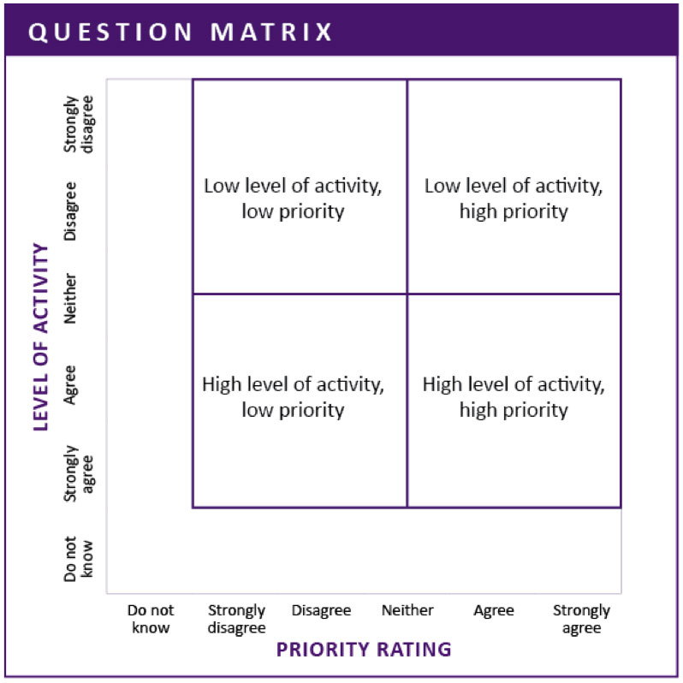
Understanding the Matrices
Look where responses fall in each activity/priority matrix. Do the questionnaire responses show a clustering in any one quadrant?

The bottom quadrants show your community’s strengths—the key aspects of a dementia-friendly community that are already in place. When you find areas that the community rates as high, take a moment to recognize/celebrate the progress already made.

The top quadrants show areas where your community may have gaps—these key aspects may be missing in your community.

To help your team identify priority actions to work on, look at the community’s ratings. Items in the right quadrants were given high priority. The upper-right quadrant (low level of activity, high priority) is the area where your community will have the best opportunity to facilitate change and move toward its vision of a dementia-friendly community. The lower-right quadrant (high level of activity, high priority) is the area where your community can continue to build on its successes. If your team wants to show early successes, this may be an area to focus on.

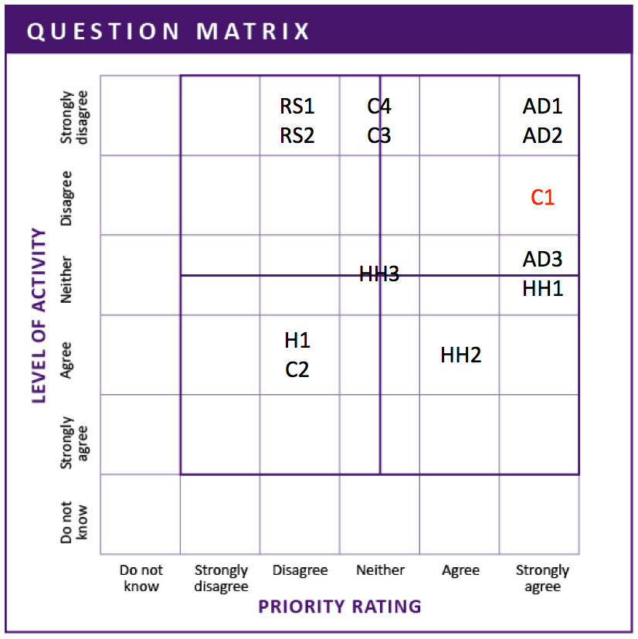
Items in the left quadrants were given a low priority. This feedback indicates that the community currently has little interest in taking action on this topic. Your team may want to conduct targeted awareness building to increase understanding about the need for these key aspects before pursuing specific strategies.

Example: Using the example from page 4, you can see the responses cluster in the upper quadrants, indicating a gap in activity. Several responses are clustered in the high priority quadrant (highlighted in purple), indicating an interest in taking action on this topic.

